

LAB TASK 03

Assumptions Taken:
- Neighbours are picked left to right so results never change
- Depth is count in edges with A at 0.
- Only A → B → E → G reaches G in the original graph & its depth is 3
- A node is visited when it leaves queue or stack and gets processed (goal too)
- Weights are 0 or more and C → G is add for Task 03 only.

Problem Description:
- A rescue robot is trapped in a building and it needs to reach the exit
- The robot get no hint at all about where the exit is located.
- Some routes are short and some are long & some also cost more to travel
- The building is shown as a graph with nodes A to G where A (Initial) is the start and G (Goal) is the exit.
- Run BFS, DFS, DLS, IDDFS and UCS on this graph and then compare the order of search, the path each one finds & the cost of that path

State-Space Definition:
- Starting state: A
- Goal check: is this node G?
- Possible actions: each corridor that leaves a node & the graph is:
  - A goes to B and C
  - B goes to D and E
  - C goes to F
  - E goes to G
  - D, F and G are end nodes ( Goal Reached )
- Cost of a path: counted as number of edge in Tasks 1 & 2 and as total corridor weight in Task 3.

Implementation Decisions:
- BFS and DFS: the code from manual Section 3.2 is used as it is and its logic is not changed. A trace copy are added to print the queue/stack state after every step.
- DLS: it is depth-limited DFS that returns one of three results: FOUND, CUTOFF or FAILURE
- IDDFS: DLS is run again and again with a bigger depth limit soo the shallow goal is found using low memory.
- Cycle Check: only current path is checked so that a valid path does not get blocked at another depth limit
- UCS: I used a priority queue that expands lowest-cost node first and keeps the insertion order when costs are equal.

Task 1:
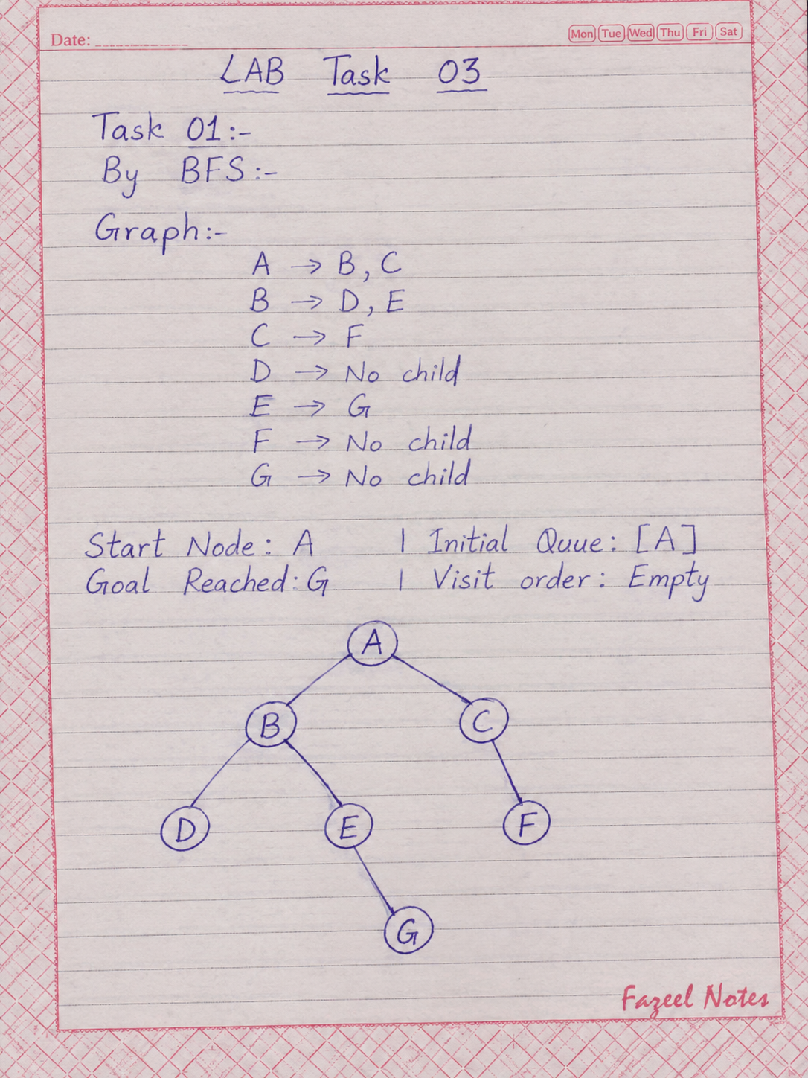
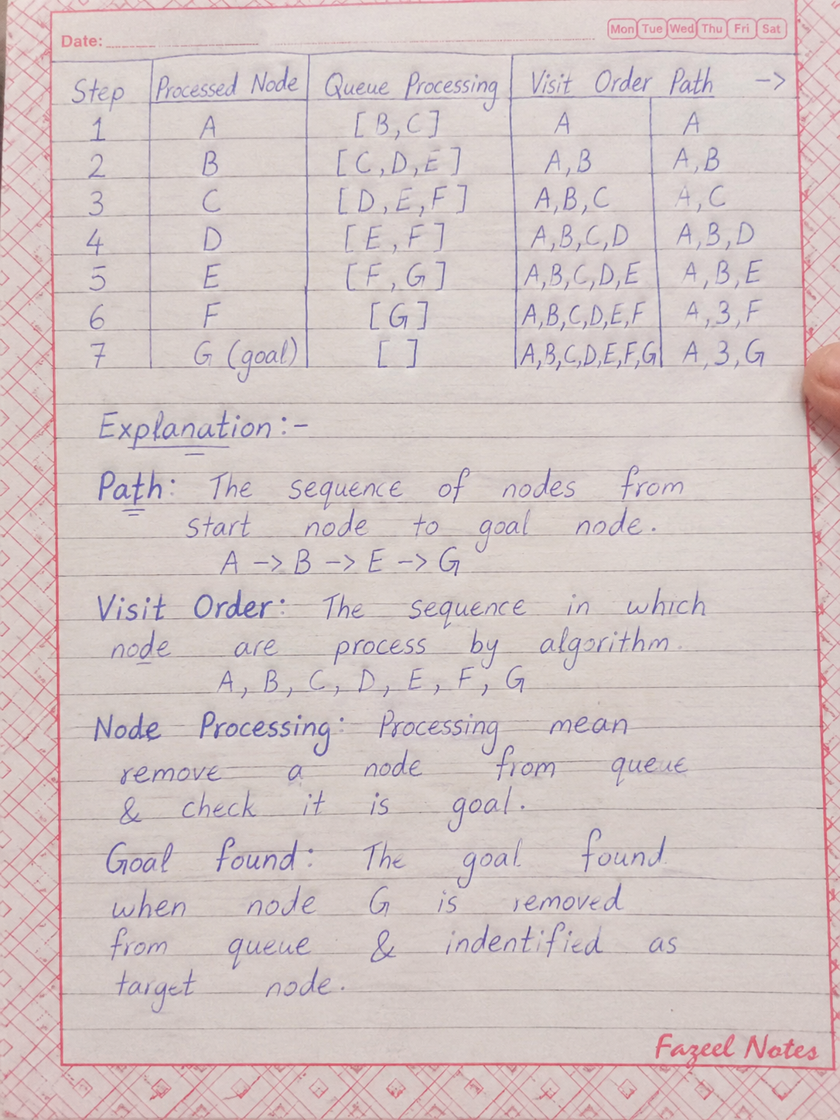
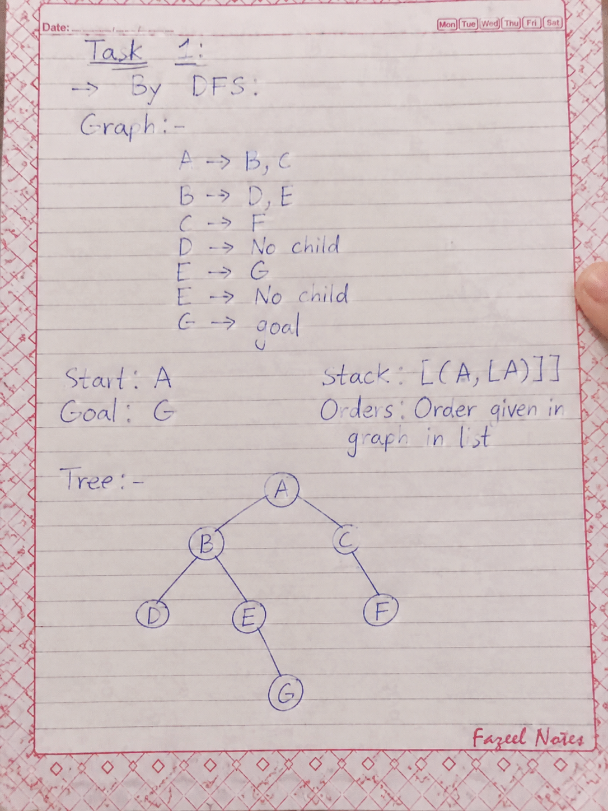
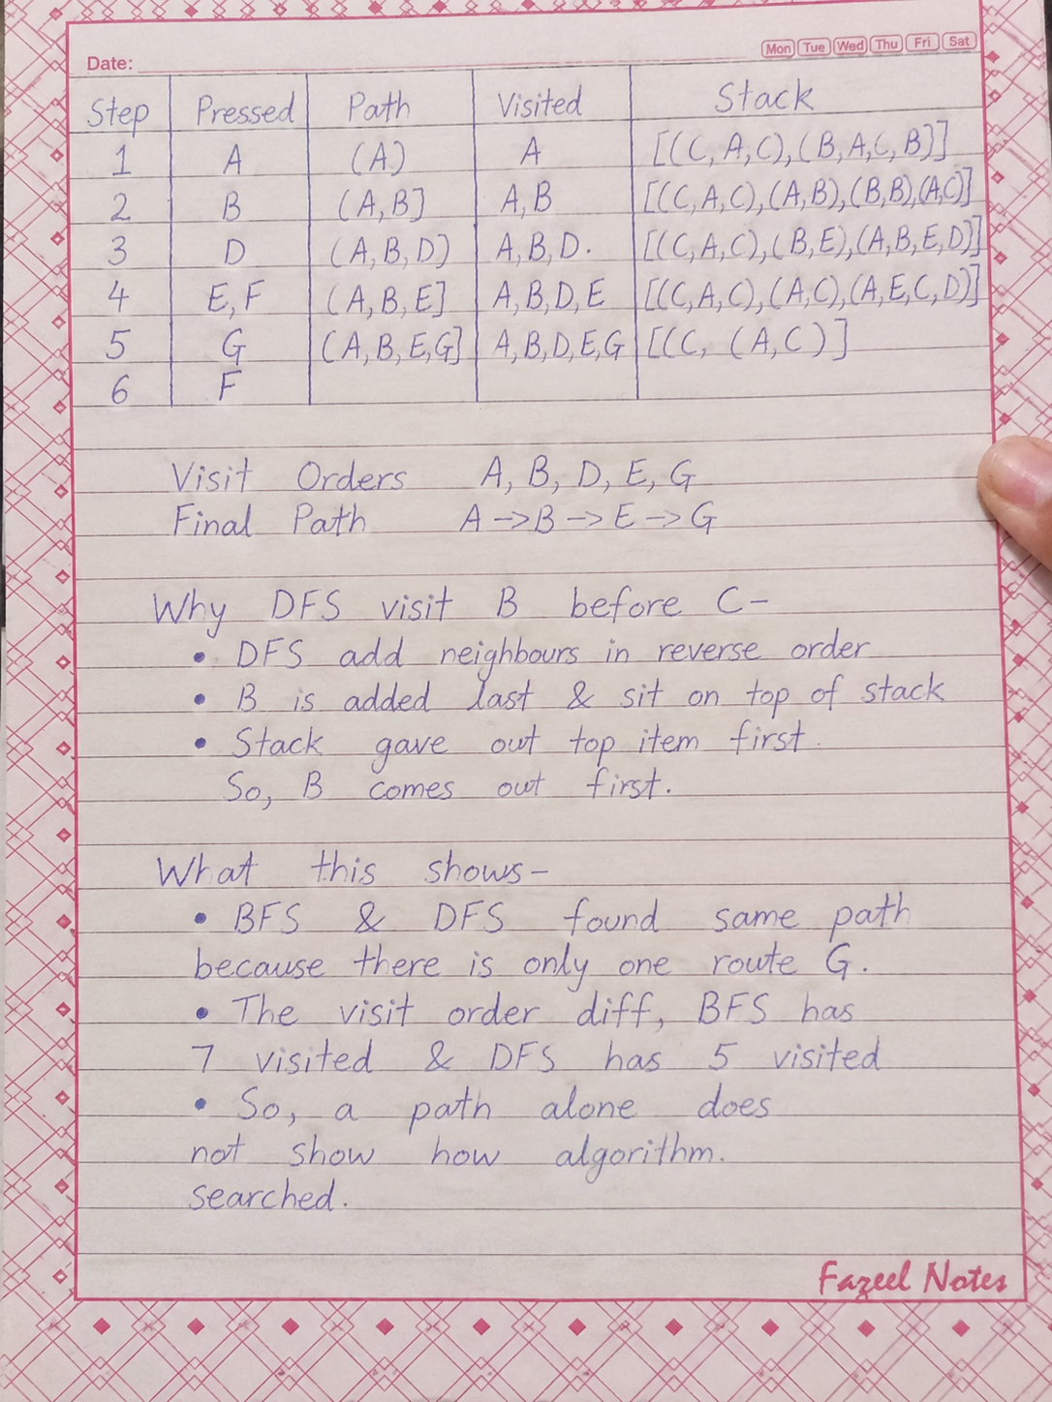
Task 2:

Results of DLS and IDDFS at limits 1–4

Result of DLS:

Limit set | Outcome | Route
1 | CUTOFF | none
2 | CUTOFF | none
3 | FOUND | A → B → E → G
4 | FOUND | A → B → E → G

Result of IDDFS:

Depth cap | Outcome | Route | Limits tried
1 | CUTOFF | None | 0 , 1
2 | CUTOFF | None | 0 , 1 , 2
3 | FOUND | A → B → E → G | 0 , 1 , 2 , 3
4 | FOUND | A → B → E → G | 0 , 1 , 2 , 3

Task 3:

Graph With Weights:
- The original node and corridors are kept the same
- I put in 1 new corridor C → G as the control extension from manual Section 3.7. It is only for this task and are not in the original graph
- Every weight is 0 or positive.

Corridor | Weight value
A → B | 1
A → C | 5
B → D | 2
B → E | 1
C → F | 2
C → G ( new ) | 7
E → G | 1

How UCS Processes the Nodes:
At each step UCS take the node with the lowest total cost so far

No. | Node processed | Total cost
1 | A | 0
2 | B | 1
3 | E | 2
4 | D | 3
5 | G (goal) | 3

- Path taken by UCS: A → B → E → G
- D and G both cost 3 but D was added first soo it came out first.
- The goal is also counted in the processing order

Cost Checked by Hand:
I added up the edge weight of the UCS path by myself & did not use the program:
- A → B = 1
- B → E = 1
- E → G = 1
- Total = 1 + 1 + 1 = 3

It matches the cost return by UCS.

Compared With BFS:
BFS ignores weights & on this graph it takes A → C → G
- A → C = 5
- C → G = 7
Total = 5 + 7 = 12

Method | Route | Edges | Cost in total
UCS | A → B → E → G | 3 | 3
BFS | A → C → G | 2 | 12

Why Fewer Hops Can Still Cost More:
- BFS only counts the number of edge and it does not look at the weights.
- A → C → G has fewer edges but both corridors in it are expensiv (5 & 7)
- UCS looks at the total cost so it pick the cheaper route with 3 edges
- Hop count and total cost are two different things so I report them seperately.

